**SOLANO COMMUNITY COLLEGE**

**MT 164, PROGRAMMABLE LOGIC CONTROLLERS**

Spring, 2018

PLC PROGRAMMING LAB 7 - INTELITEK SERVO MOTOR

**Catharine Crayne**

**04/08/2018**

**OBJECTIVE**:

1. To write a ladder logic program the will control a DC Servo Motor.

**Group Members**

**N/A**

**MATERIALS**: Micrologix 1100 Trainer Unit, Intelitek PLCLine Trainer, 8 banana plug wires, RSLinx and RSLogix software, laptop, crossover cable.

**SAFETY AND EQUIPMENT NOTES:**

1. Turn off trainer when attaching wires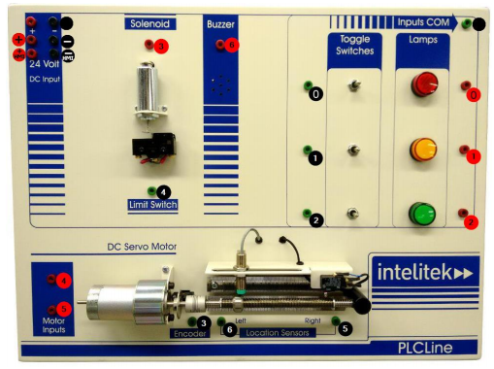

**PROCEDURE**:

**Intelitek Trainer: Part 1**

1. Design a ladder logic program that will run the DC Servo Motor, through connection 4, when the Top Toggle Switch is momentarily on (moved to the right). While the toggle switch is ON, the Red Lamp should also come on.
2. With your Micrologix PLC Trainer, connect banana plug wires that will connect to the toggle switch and the two outputs (red lamp and motor-4)
3. While some of the connections on the Intelitek PLCLine trainer are available to plug into, others are hidden from view. Basically one side of all the connections connect to the “Inputs COM”. Make a banana plug connector for your COM on your trainer.
4. Download your program to your Micrologix PLC trainer. Then connect to one of the Intelitek trainers. Verify that it works. Document the setup. Which way does the “lead nut” go on the lead screw? **Right**
5. Using a multi-meter, set it up to measure current. Break the connection to motor input-4 and insert your meter in between the broken connection. How much current draw there is while the motor is running?

**Intelitek Trainer: Part 2**

1. Now modify/add to your program so that the motor will move to the right until the right limit switch is activated, then reverse its direction until the left limit switch is activated. Keep the top toggle switch as the main on/off function for this, with the red lamp as the pilot light.
2. Connect two more banana plug wires to your inputs for the limit switches and another plug wire for reversing the motor direction.
3. Download your program to your Micrologix PLC trainer. Then connect to one of the Intelitek trainers. Verify that it works. Document the setup.

**Intelitek Trainer: Part 3**

1. Once again modify your program so that it counts the revolutions using the encoder. Have the counter begin at one end and count until the lead nut gets to the other end.
2. Connect one more banana plug wire to your input for the encoder. Download your program to your Micrologix PLC trainer. Then connect to one of the Intelitek trainers. Verify that it works. Document the setup. How many rotations does the output make from one side to the other? **47 rotations**
3. **BONUS**: Using a timer and the counter, modify your program to calculate the RPM of the lead screw.

**RESULTS - DATA**

Step 2: Snapshot of our program.

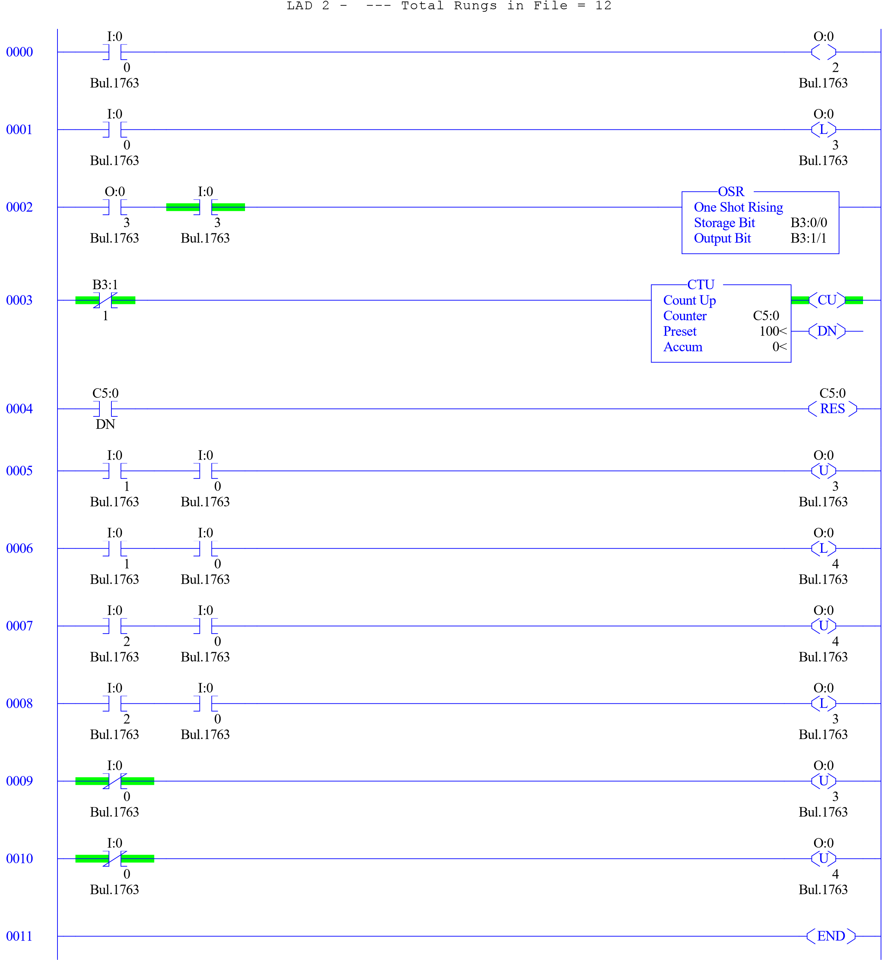

**OBSERVATIONS**

Pictures of my setup

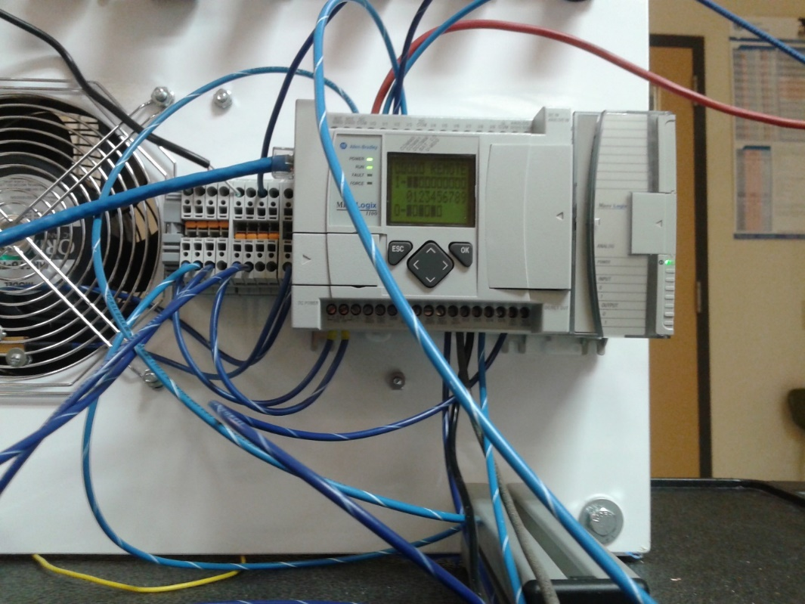

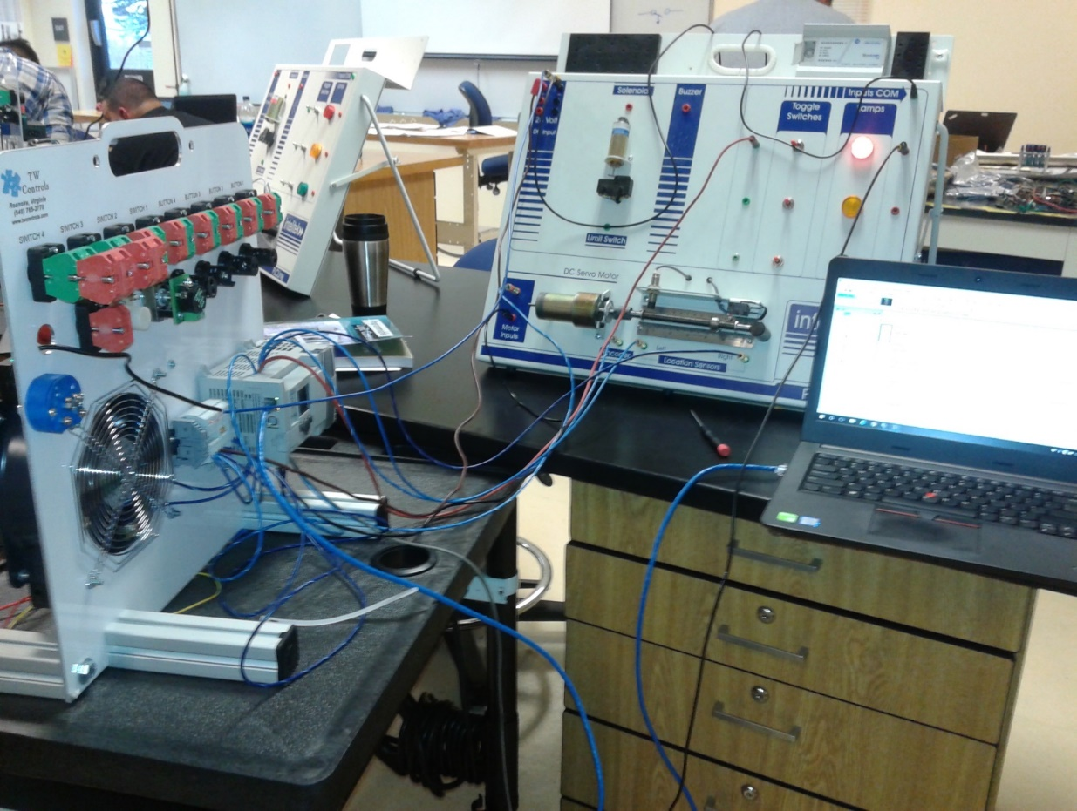

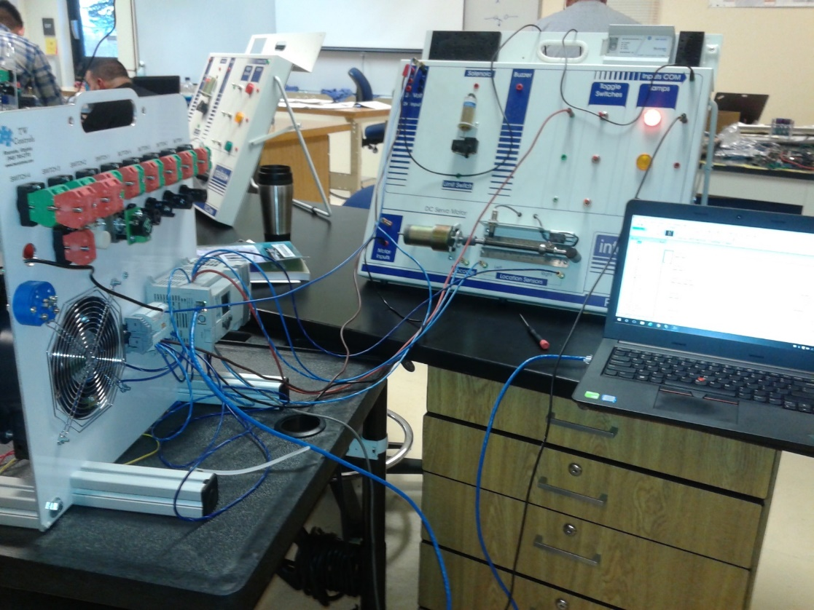

**ANALYSIS QUESTIONS:**

1. The motor used in this lab is a 24VDC motor. What should we change about this setup if we instead wanted to use a larger 120VAC motor?

*If you want to run a 120 VAC motor, the output terminals need to be the current source. The input can only supply 24 VDC.*

1. If one of the limit switches is broken or incorrectly programmed, what might happen when the lead nut reaches the end of its travel?

*The motor may continue to operate, turning in the same direction, potentially resulting in damage to the equipment.*

1. What is the max output current the Micrologix 1100 can support?

*This configuration allows a low-voltage 24-volt control signal to control 240-volt output devices.*

1. What is the most common and dangerous mistake people might make when using a multimeter to measure current through a device?

*Touching one of the metal rods while the other rod is touching the device that is being measured.*